

**Project1: Pressure Controller**

Eng. Ali Mohamed Taima



Learn in depth

Mastering Embedded System online diploma

Eng. Keroles

# Embedded System Architecting/Design Sequence

## Case Study

A ”client” expects you to deliver the software of  
the following system:  
▶ Specification (from the client)  
▶ A pressure controller informs the crew of a cabin  
with an alarm when the pressure exceeds 20 bars inthe cabin▶ The alarm duration equals 60 seconds.

▶ Pressure Controller: Assumptions  
▶ The controller set up and shutdown procedures are  
not modeled  
▶ The controller maintenance is not modeled  
▶ The pressure sensor never fails  
▶ The alarm never fails  
▶ The controller never faces power cut

## Method

I choose the Agile Scrum methodology to work with my project

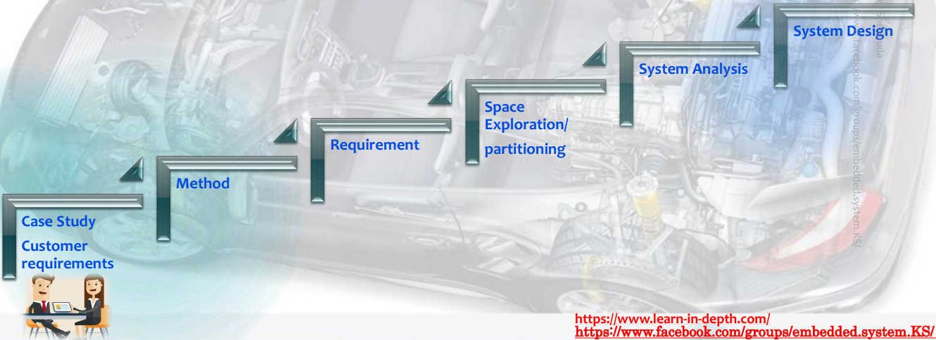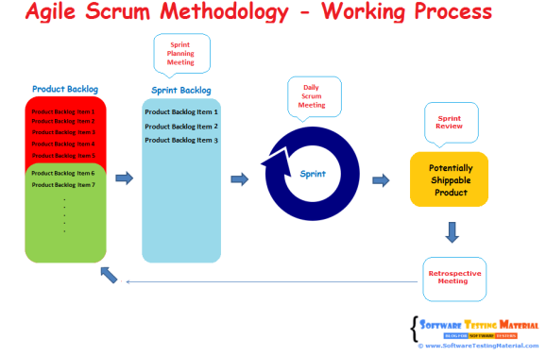

## Requirements

Here are the requirements in the project

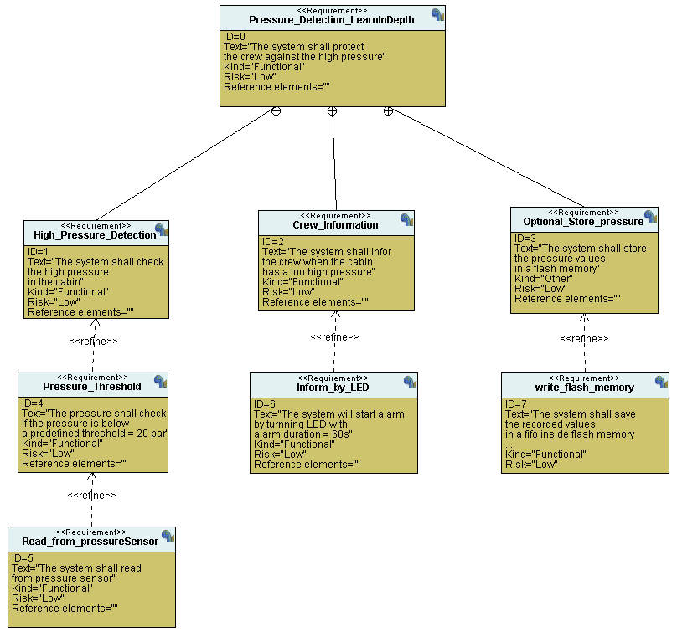

## Space Exploration/partitioning

After some search I found that the best MC that fit my project is STMF103

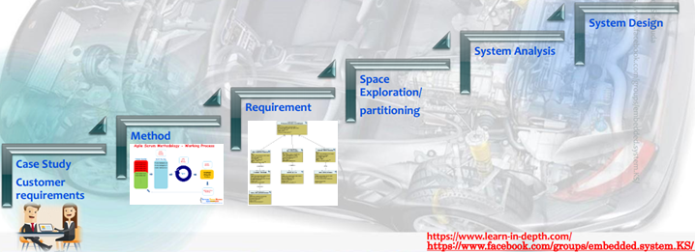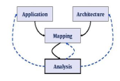

## System Analysis

### A diagram of a system Description automatically generatedUML:Use Case Diagram

### A diagram of a program Description automatically generatedUML: Activity Diagram

### A diagram of a fire alarm system Description automatically generatedUML: Sequence Diagram



**1. Use Case Diagram**

**2. Activity Diagram**

**3. Sequence Diagram**

## System Design

### A computer screen shot of a computer Description automatically generatedBlock Diagram of the system

### Main Algorithm

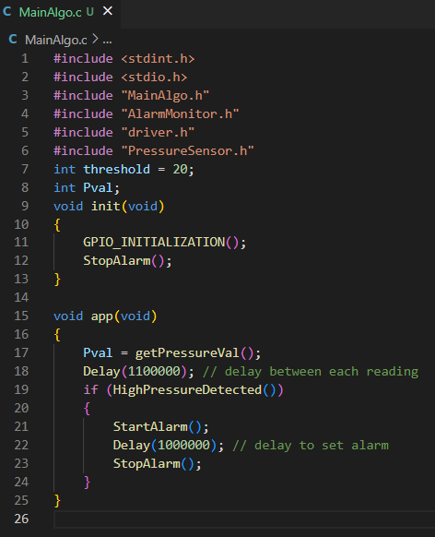

### A screen shot of a computer program Description automatically generatedA diagram of a program Description automatically generatedPressure Sensor Driver

**A screen shot of a computer program Description automatically generatedA diagram of a system Description automatically generatedAlarm Monitor

### A screen shot of a computer program Description automatically generatedAlarm Actuator Driver



**1. Use Case Diagram**

**2. Activity Diagram**

**3. Sequence Diagram**

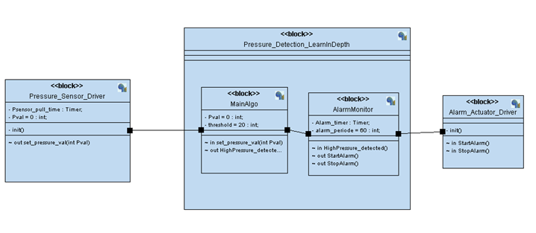

# Simulation test

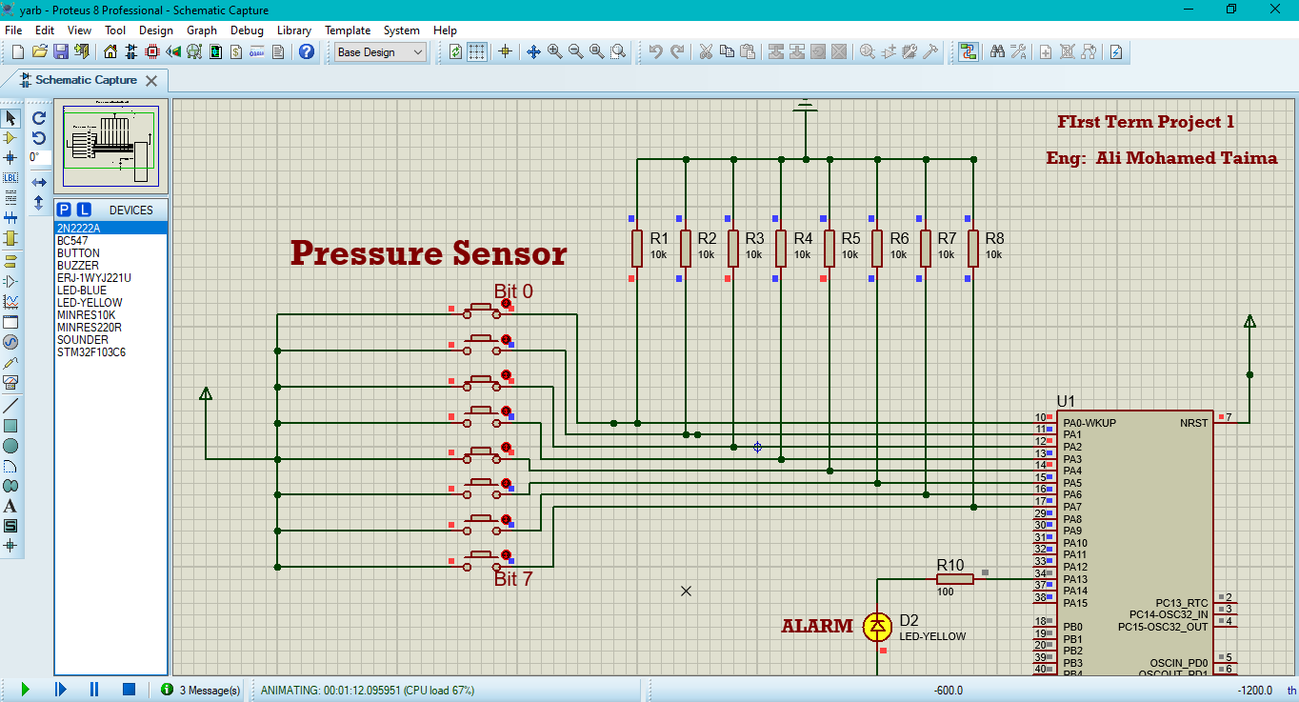For binary 0001 0101 which is 21 and make High pressure detected the so the alarm get on for 60 seconds

When I try binary 0000 1111 which is 15 (below the threshold 20) so nothing happen and the alarm still off

For binary 0011 0010 which is 50 and make High pressure detected the so the alarm get on for 60 seconds

When I try binary 0000 1010 which is 10 (below the threshold 20) so nothing happen and the alarm still off

# SW analysis

## .map file

Allocating common symbols

Common symbol size file

Pval 0x4 MainAlgo.o

Memory Configuration

As I write in the linker file the memory initialized

Name Origin Length Attributes

flash 0x08000000 0x00020000 xr

sram 0x20000000 0x00005000 xrw

*default* 0x00000000 0xffffffff

Linker script and memory map

I compine the different sections with each other as in my linker

**.text** 0x08000000 0x2a0

**\*(.vectors*)**

.vectors 0x08000000 0x1c startup.o

0x08000000 vectors

**\*(.text*)**

.text 0x0800001c 0xbc startup.o

0x0800001c NMI_Handler

.text section

0x0800001c Bus_Fault_Handler

0x0800001c Usage_Fault_Handler

0x0800001c Default_Handler

0x0800001c H_fault_Handler

0x0800001c NM_Fault_Handler

0x08000028 Reset_Handler

.text 0x080000d8 0x10 main.o

0x080000d8 main

.text 0x080000e8 0x3c PressureSensor.o

0x080000e8 HighPressureDetected

.text 0x08000124 0x50 MainAlgo.o

0x08000124 init

0x08000134 app

.text 0x08000174 0x10c driver.o

Cont.  
.text section

0x08000174 Delay

0x08000198 getPressureVal

0x080001b0 Set_Alarm_actuator

0x08000200 GPIO_INITIALIZATION

.text 0x08000280 0x20 AlarmMonitor.o

0x08000280 StartAlarm

0x08000290 StopAlarm

**\*(.rodata)**

0x080002a0 **_E_text = .**

.glue_7 0x080002a0 0x0

.glue_7 0x00000000 0x0 linker stubs

.glue_7t 0x080002a0 0x0

.glue_7t 0x00000000 0x0 linker stubs

.vfp11_veneer 0x080002a0 0x0

.vfp11_veneer 0x00000000 0x0 linker stubs

.v4_bx 0x080002a0 0x0

.v4_bx 0x00000000 0x0 linker stubs

.iplt 0x080002a0 0x0

.iplt 0x00000000 0x0 startup.o

.rel.dyn 0x080002a0 0x0

.rel.iplt 0x00000000 0x0 startup.o

**.data** 0x20000000 0x4 load address 0x080002a0

0x20000000 **_S_DATA = .**

**\*(.data)**

.data 0x20000000 0x0 startup.o

.data 0x20000000 0x0 main.o

.data 0x20000000 0x0 PressureSensor.o

.data section

.data 0x20000000 0x4 MainAlgo.o

0x20000000 threshold

.data 0x20000004 0x0 driver.o

.data 0x20000004 0x0 AlarmMonitor.o

0x20000004 **_E_DATA = .**

.igot.plt 0x20000004 0x0 load address 0x080002a4

.igot.plt 0x00000000 0x0 startup.o

**.bss** 0x20000004 0x1004 load address 0x080002a4

0x20000004 **_S_bss = .**

**\*(.bss)**

.bss 0x20000004 0x0 startup.o

.bss 0x20000004 0x0 main.o

.bss 0x20000004 0x0 PressureSensor.o

.bss section

.bss 0x20000004 0x0 MainAlgo.o

.bss 0x20000004 0x0 driver.o

.bss 0x20000004 0x0 AlarmMonitor.o

0x20000004 **. = ALIGN (0x4)**

0x20000004 **_E_bss = .**

0x20000004 **. = ALIGN (0x4)**

0x20001004 **. = (. + 0x1000)**

*fill* 0x20000004 0x1000

Stack top

0x20001004 **_stack_top = .**

COMMON 0x20001004 0x4 MainAlgo.o

0x20001004 Pval

LOAD startup.o

LOAD main.o

LOAD PressureSensor.o

LOAD MainAlgo.o

LOAD driver.o

LOAD AlarmMonitor.o

OUTPUT(Project1_pressure_controller.elf elf32-littlearm)

.debug_info 0x00000000 0x496

.debug_info 0x00000000 0x168 startup.o

.debug_info 0x00000168 0x46 main.o

.debug_info 0x000001ae 0x75 PressureSensor.o

.debug_info 0x00000223 0xca MainAlgo.o

.debug_info 0x000002ed 0x103 driver.o

.debug_info 0x000003f0 0xa6 AlarmMonitor.o

.debug_abbrev 0x00000000 0x2a5

.debug_abbrev 0x00000000 0xc2 startup.o

.debug_abbrev 0x000000c2 0x37 main.o

.debug_abbrev 0x000000f9 0x62 PressureSensor.o

.debug_abbrev 0x0000015b 0x6b MainAlgo.o

.debug_abbrev 0x000001c6 0x9d driver.o

.debug_abbrev 0x00000263 0x42 AlarmMonitor.o

.debug_loc 0x00000000 0x234

.debug_loc 0x00000000 0x64 startup.o

.debug_loc 0x00000064 0x2c main.o

.debug_loc 0x00000090 0x2c PressureSensor.o

.debug_loc 0x000000bc 0x58 MainAlgo.o

.debug_loc 0x00000114 0xc8 driver.o

.debug_loc 0x000001dc 0x58 AlarmMonitor.o

.debug_aranges 0x00000000 0xc0

.debug_aranges

0x00000000 0x20 startup.o

.debug_aranges

0x00000020 0x20 main.o

.debug_aranges

0x00000040 0x20 PressureSensor.o

.debug_aranges

0x00000060 0x20 MainAlgo.o

.debug_aranges

0x00000080 0x20 driver.o

.debug_aranges

0x000000a0 0x20 AlarmMonitor.o

.debug_line 0x00000000 0x24e

.debug_line 0x00000000 0xad startup.o

.debug_line 0x000000ad 0x3f main.o

.debug_line 0x000000ec 0x43 PressureSensor.o

.debug_line 0x0000012f 0x45 MainAlgo.o

.debug_line 0x00000174 0x99 driver.o

.debug_line 0x0000020d 0x41 AlarmMonitor.o

.debug_str 0x00000000 0x1fc

.debug_str 0x00000000 0x13b startup.o

0x16f (size before relaxing)

.debug_str 0x0000013b 0xc main.o

0x65 (size before relaxing)

.debug_str 0x00000147 0x44 PressureSensor.o

0x9d (size before relaxing)

.debug_str 0x0000018b 0x10 MainAlgo.o

0x10a (size before relaxing)

.debug_str 0x0000019b 0x3d driver.o

0x140 (size before relaxing)

.debug_str 0x000001d8 0x24 AlarmMonitor.o

0x10f (size before relaxing)

.comment 0x00000000 0x11

.comment 0x00000000 0x11 startup.o

0x12 (size before relaxing)

.comment 0x00000000 0x12 main.o

.comment 0x00000000 0x12 PressureSensor.o

.comment 0x00000000 0x12 MainAlgo.o

.comment 0x00000000 0x12 driver.o

.comment 0x00000000 0x12 AlarmMonitor.o

.ARM.attributes

0x00000000 0x33

.ARM.attributes

0x00000000 0x33 startup.o

.ARM.attributes

0x00000033 0x33 main.o

.ARM.attributes

0x00000066 0x33 PressureSensor.o

.ARM.attributes

0x00000099 0x33 MainAlgo.o

.ARM.attributes

0x000000cc 0x33 driver.o

.ARM.attributes

0x000000ff 0x33 AlarmMonitor.o

.debug_frame 0x00000000 0x1a8

.debug_frame 0x00000000 0x48 startup.o

.debug_frame 0x00000048 0x2c main.o

.debug_frame 0x00000074 0x2c PressureSensor.o

.debug_frame 0x000000a0 0x48 MainAlgo.o

.debug_frame 0x000000e8 0x78 driver.o

.debug_frame 0x00000160 0x48 AlarmMonitor.o